Lab Assignent-6.5

Batch-35

HT NO-2303A52462

Task 1: Prompt:
“Generate Python code to check voting eligibility based on age and
citizenship.”
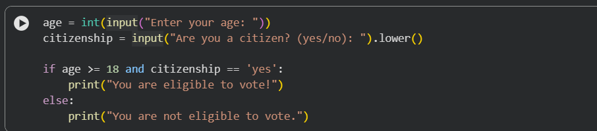
Output:
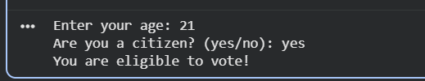
Explanation:
• Age Condition
- age >= 18
- Ensures the person meets the minimum voting age requirement.
• Citizenship Condition
- citizenship.lower() == "yes"
- Converts input to lowercase so inputs like Yes, YES, or yes are all accepted.
• Logical AND (and)
- Both conditions must be true for the person to be eligible.
- If either age is below 18 or citizenship is not "yes", voting is not allowed.
Task 2: Generate Python code to count vowels and consonants in a string using loops
Code:
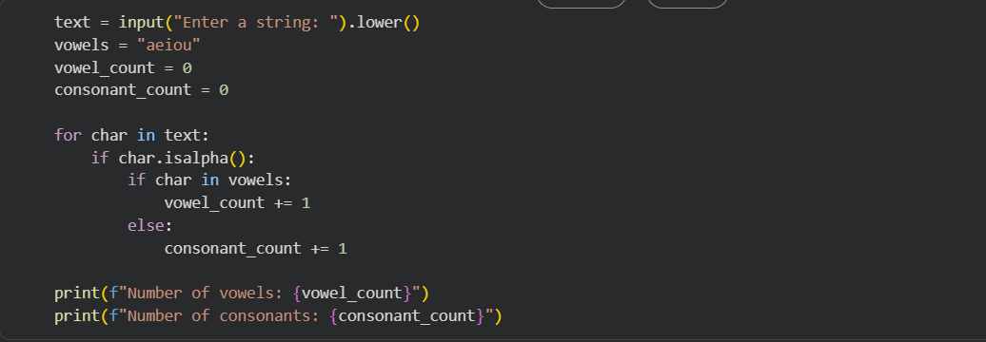
Output:
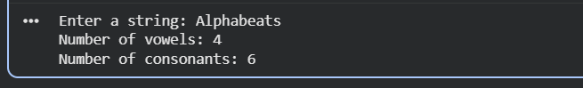
Task 3: Generate a Python program for a library management system
using classes, loops, and conditional statements.
Code:
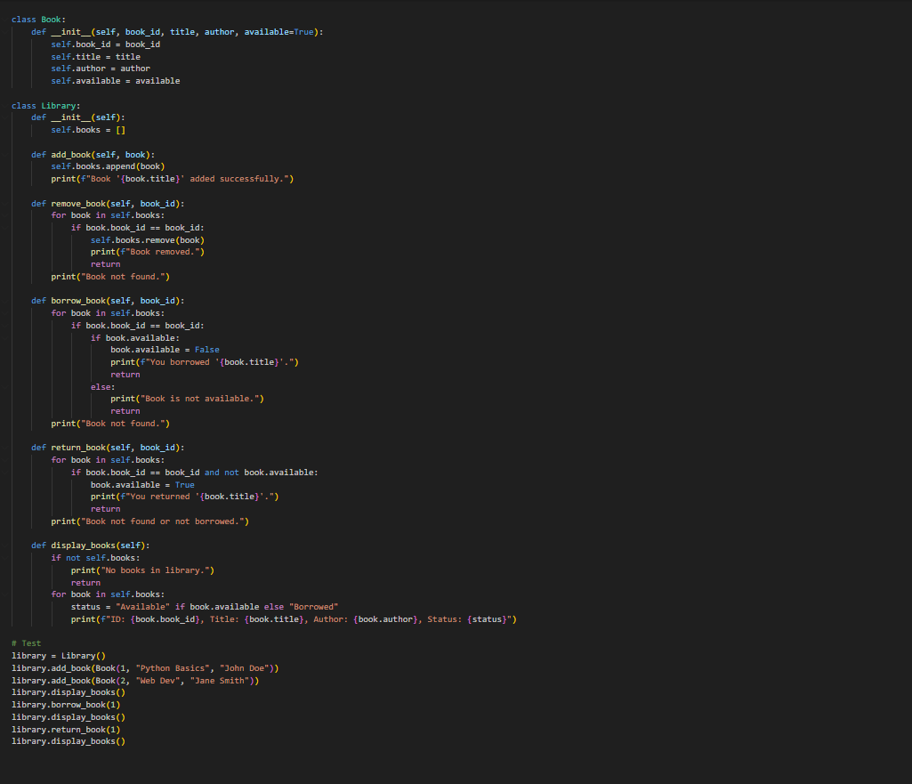
Output:
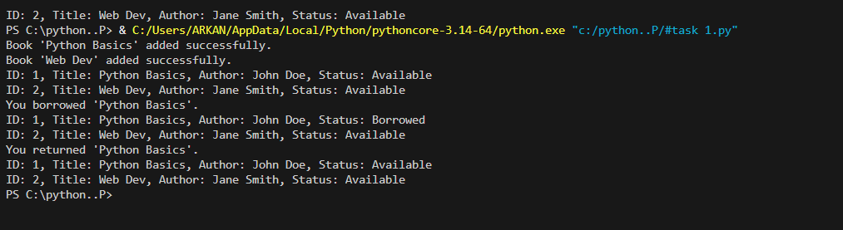
Task 4: Use an AI tool to generate an attendance management class.
Prompt: “Generate a Python class to mark and display student
attendance using loops.”
Code:
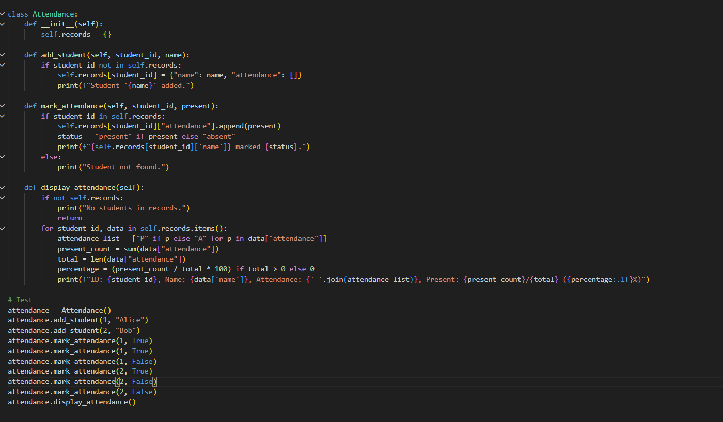
Output:
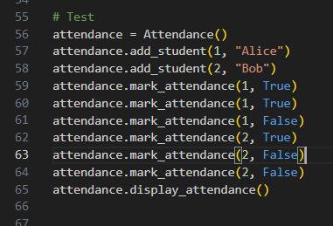

Task 5: Generate a Python program using loops and conditionals
to simulate an ATM menu.”
Code:
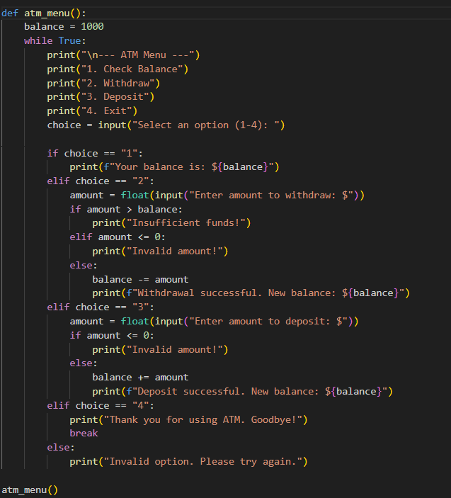
Output:
